Friends and Family Comments June 2023
RESULTS: 104

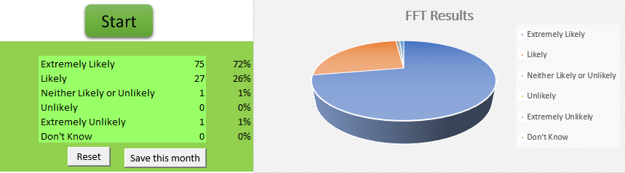

- Very pleasant
- Quick and efficient
- Very efficient
- The appointment was quick and doctor very friendly
- The nurse I was very helpful she explained about my blood pressuer about caffeine intake about my diet she was most helpful and she put me at ease
- Because you asked
- Dr Jeyam, is one of the nicest doctors I've dealt with over the years, lovely and friendly, she understands, is compassionate and very friendly. Dr Jeyam, puts me at ease every time
- Was treated rightly and feel like I might be closer to getting my illness sorted
- It’s nice to be nice
- Very quick service
- My doctor’s surgery are the best when it comes to any personal matters or any other issues regarding health &amp; wellbeing, including reception staff...
- The nurse was very good
- The doctor I saw today. Was the best doctor I have seen for a long time... did a proper examination instead of guessing. And didn't rush to get me out the door. (Dr Christopher Sefton)... keep this doctor
- Because I thought everything went well
- Seen on time, thorough examination, everything explained
- I was extremely impressed with the thoroughness of my appointment
- It was the nurse I saw
- Very understanding and polite
- The staff was very understanding
- Prompt appointment time and blood taken no problem
- I have always had great treatment and support from all staff at the surgery. Most recently, Ian Hadlow has been fantastic
- I hadn't made an appointment
- Nurse was very thorough friendly and patient, everything explained fully to me fully
- Went like clockwork start to finish
- Quick and on time appointment
- Very helpful reception staff, medical professional was very professional and friendly. Appointment was easy to book and ran on time
- Because GP there is very good
- Met practice nurse Mollie for the first time today and she was thorough, kind and thoughtful. On the whole a very pleasant experience
- Everything was explained to me and no rush had time to talk Thank you
- Nurse Janine was very professional , she explained everything in full and if i did not quite follow it she would go through it again , she answered any question i asked fully , she is a credit to our precise , thanks Janine
- Appointment was on time, surgery was clean and comfortable, reception staff friendly and helpful
- I am happy with the meeting
- Excellent service by all staff involved in my appointment
- No waiting
- Was very chatty and gave me some good tips
- Mert ez az igazsag (because this is the truth)
- I love all team of my GP I’m really thankful for help me
- Really nice Dr very well done her job ???? impressive
- I was very pleased with the outcome of the appointment
- It was efficient
- Polite listens professional
- Because she checked me with care and patient
- Quality service at reception. Excellent medical action. Totally painless blood sample taken. Very friendly service and reassuring. Thank you very much
- Very efficient and friendly. Excellent customer service/care
- Locum doctor new guy is fab
- Good treatment offered
- The nurse was very thorough. Listened to me and made suggestions to see the doctor for follow up. She was very pleasant. She took bloods without any pain. She was very efficient
- On time
- Excellent work
- Overall it was a quick and easy appointment
- It was good the GP understood and listen to what I had to say
- Yes all staff an Doctors are so helpful
- In early, consultation excellent
- Excellent speedy service
- It was my first time meeting Janine, she was very friendly and made me feel at ease. Janine explained everything she was doing and why
- I arrived on time, I was seen on time and dealt with efficiently. No problem
- Appointment in time got everything I needed from the review
- Was very friendly
- Always ready to Help
- always pleasant all the way from reception to consultation
- I’m not satisfied
- Good service
- On time, service excellent

